Composite Solids

Definition
# Source: AI Source: Provided by: [Data Path: Persons Table -> ID Column: 1, Name_En Column: Motasem Essam] -> From: [ChatGPT] on [7/25/2026]
A composite solid is a three-dimensional geometric object formed by combining two or more simpler solids into one shape.
The component solids may be joined together, placed on top of one another, or formed by removing one solid from another. The resulting object is treated as a single solid for geometric calculations.
Composite solids can combine:
- Polyhedra, such as cubes, cuboids, prisms, and pyramids.
- Solids with curved surfaces, such as cylinders, cones, and hemispheres.
- Both flat-faced and curved solids in the same object.
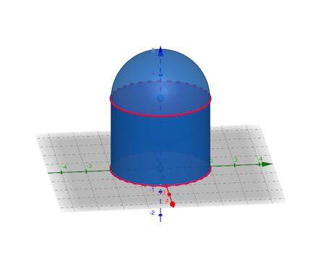
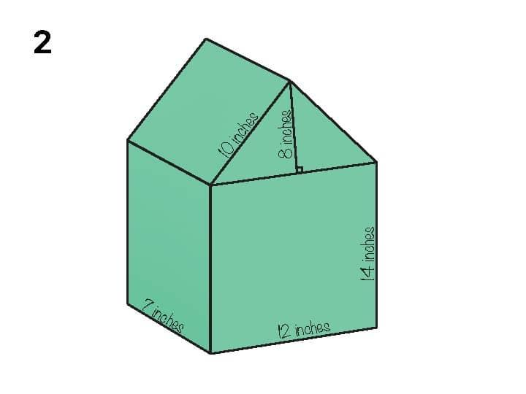


Simple definition
# Source: AI Source: Provided by: [Data Path: Persons Table -> ID Column: 1, Name_En Column: Motasem Essam] -> From: [ChatGPT] on [7/25/2026]
A composite solid is a 3D shape made by joining or combining simpler 3D shapes.
For example:
- A house-shaped model can be made from a cuboid and a triangular prism.
- A capsule-shaped model can be made from a cylinder and two hemispheres.
- A tower-shaped model can be made from a cylinder and a cone.
- A stepped block can be made from two or more cuboids.
The important idea is that the combined object can be analyzed by studying its simpler components.

Main types of composite solids

1. Composite solids formed by addition
# Source: AI Source: Provided by: [Data Path: Persons Table -> ID Column: 1, Name_En Column: Motasem Essam] -> From: [ChatGPT] on [7/25/2026]
These are created by joining two or more solids together without removing material from the components.
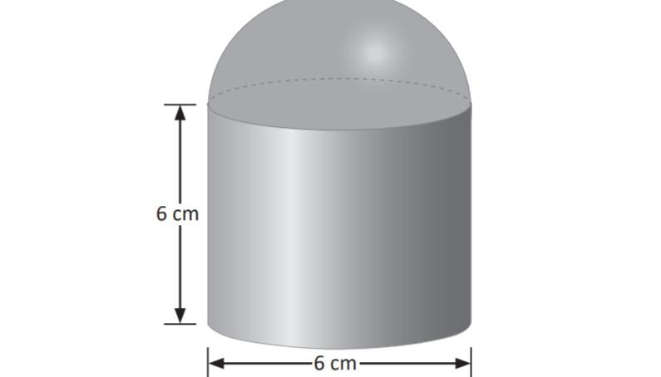
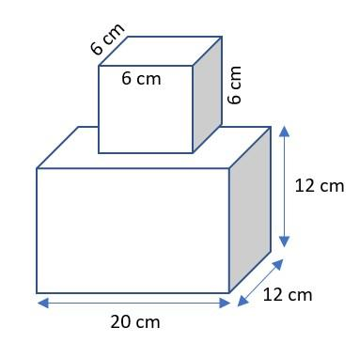
Examples include:
- A cuboid with a smaller cuboid attached.
- A cylinder topped by a hemisphere.
- A cuboid with a triangular-prism roof.
- A cylinder joined to a cone.
If the components do not overlap in volume, the total volume is the sum of their volumes:
$$V_{\text{total}}=V_{1}+V_{2}+⋯+V_{n}$$
If components overlap, the overlapping volume must not be counted twice.

2. Composite solids formed by subtraction
# Source: AI Source: Provided by: [Data Path: Persons Table -> ID Column: 1, Name_En Column: Motasem Essam] -> From: [ChatGPT] on [7/25/2026]
These are created by removing one solid or a portion of a solid from another.
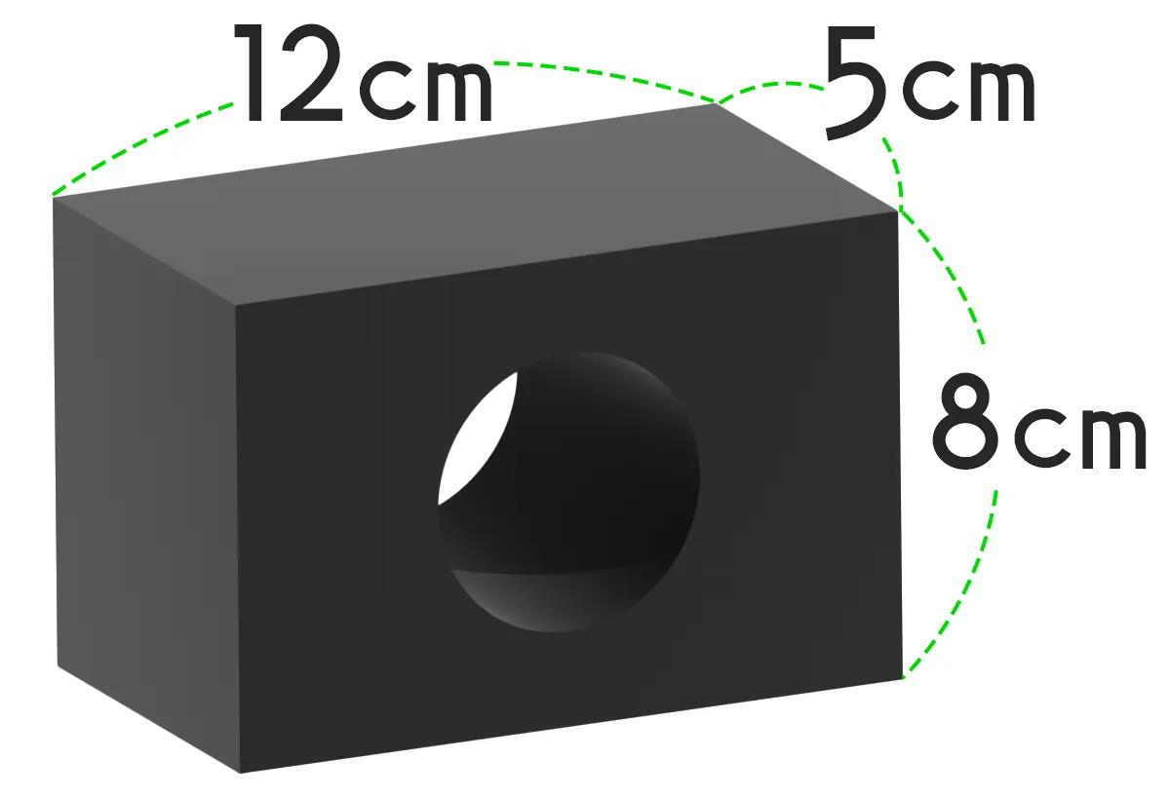
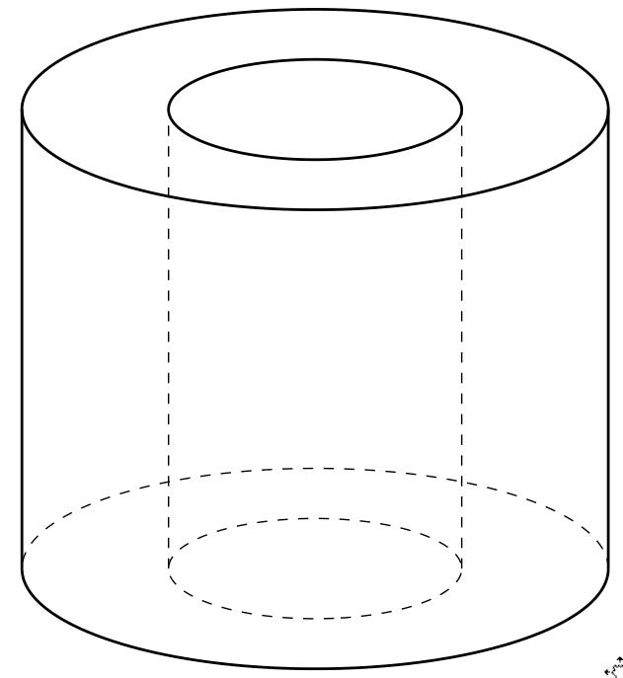
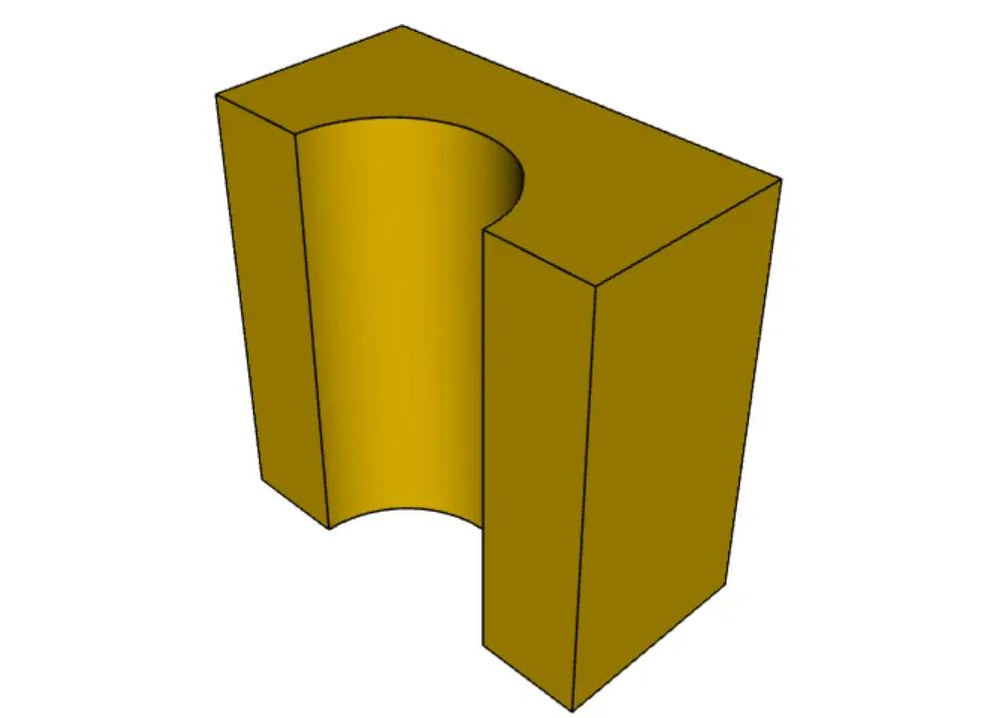
Examples include:
- A cuboid with a cylindrical hole.
- A cylinder with a smaller cylindrical cavity.
- A block with a notch removed.
- A solid sphere with a spherical cavity.
For a solid formed by removing a smaller region from a larger solid:
$$V_{\text{remaining}}=V_{\text{original}}-V_{\text{removed}}$$
The removed portion must lie within the original solid, and the dimensions must describe the actual removed volume.

3. Composite solids with flat and curved surfaces
# Source: AI Source: Provided by: [Data Path: Persons Table -> ID Column: 1, Name_En Column: Motasem Essam] -> From: [ChatGPT] on [7/25/2026]
These combine components with different types of surfaces.

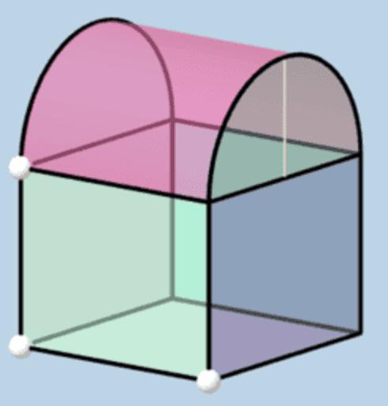
Examples include:
- A cuboid with a cylindrical column.
- A cylinder joined to a cone.
- A rectangular block with a semicylindrical roof.
- A hemisphere placed on a cuboid.
Such objects require both the formulas for polyhedra and the formulas for curved solids.

4. Composite solids with repeated components
# Source: AI Source: Provided by: [Data Path: Persons Table -> ID Column: 1, Name_En Column: Motasem Essam] -> From: [ChatGPT] on [7/25/2026]
These contain several components that may be identical or follow a repeated pattern.
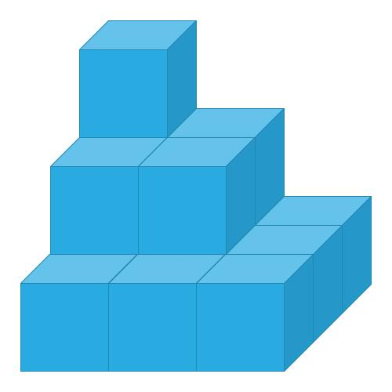
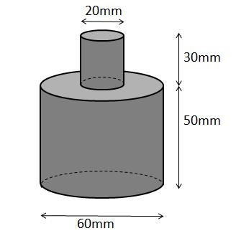
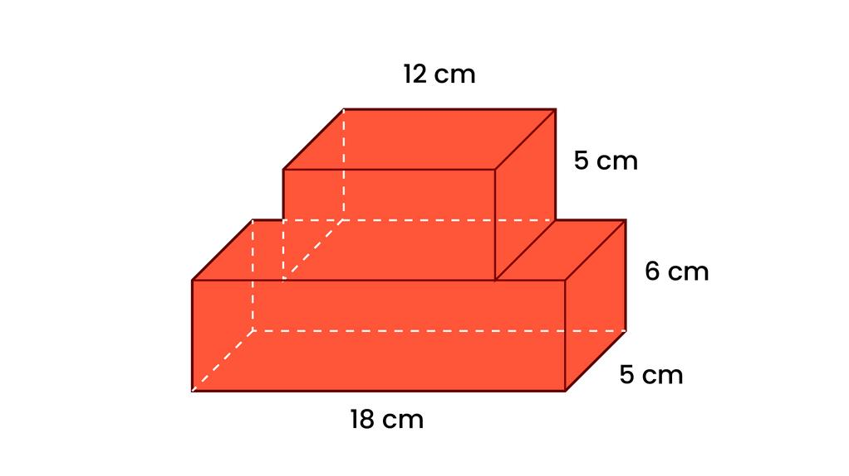
Examples include:
- A staircase-shaped block made from cuboids.
- A stack of cylindrical sections.
- A stepped platform made from cubes.
- A structure formed from several equal prisms.
When the components are identical and do not overlap, the volume can be calculated by multiplying the volume of one component by the number of components.
$$V_{\text{total}}=nV_{\text{component}}$$
Here, $n$ is the number of identical components.

Key characteristics
# Source: AI Source: Provided by: [Data Path: Persons Table -> ID Column: 1, Name_En Column: Motasem Essam] -> From: [ChatGPT] on [7/25/2026]
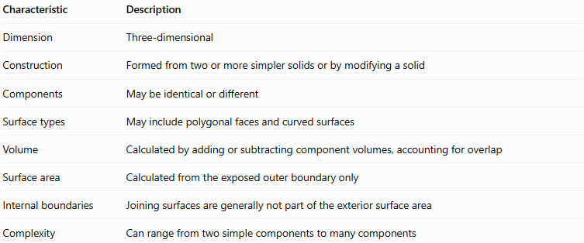
Characteristic | Description
Dimension | Three-dimensional
Construction | Formed from two or more simpler solids or by modifying a solid
Components | May be identical or different
Surface types | May include polygonal faces and curved surfaces
Volume | Calculated by adding or subtracting component volumes, accounting for overlap
Surface area | Calculated from the exposed outer boundary only
Internal boundaries | Joining surfaces are generally not part of the exterior surface area
Complexity | Can range from two simple components to many components

Important geometric rule: exposed surface area
# Source: AI Source: Provided by: [Data Path: Persons Table -> ID Column: 1, Name_En Column: Motasem Essam] -> From: [ChatGPT] on [7/25/2026]
The surface area of a composite solid is not always the sum of the complete surface areas of its components.
When two solids are joined along a face or surface, the joined parts become internal and are no longer exposed to the outside.
For example, when two cubes are joined face-to-face, their two touching square faces must be excluded from the exterior surface area.
If two solids are joined across a common interface of area $A$, and that interface is entirely hidden, then:
$$S_{\text{total}}=S_{1}+S_{2}-2A$$
This formula assumes that the only hidden surface portions are the two matching interface regions and that no other overlap or covering occurs.
For more complicated composite solids, identify and add all exposed surface portions individually.

Mathematical representations and formulas
# Source: AI Source: Provided by: [Data Path: Persons Table -> ID Column: 1, Name_En Column: Motasem Essam] -> From: [ChatGPT] on [7/25/2026]
Composite solids do not have one universal volume or surface-area formula. Their calculations depend on the component shapes and how those shapes are combined.

1. Volume of common components
# Source: AI Source: Provided by: [Data Path: Persons Table -> ID Column: 1, Name_En Column: Motasem Essam] -> From: [ChatGPT] on [7/25/2026]
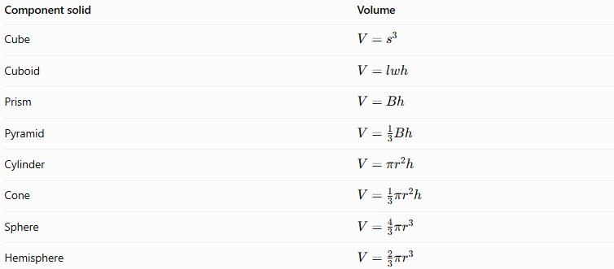
Component solid | Volume
Cube | $$V=s^{3}$$
Cuboid | $$V=lwh$$
Prism | $$V=Bh$$
Pyramid | $$V=\frac{1}{3}Bh$$
Cylinder | $$V=πr^{2}h$$
Cone | $$V=\frac{1}{3}πr^{2}h$$
Sphere | $$V=\frac{4}{3}πr^{3}$$
Hemisphere | $$V=\frac{2}{3}πr^{3}$$
Here, $B$ is the area of the base, $s$ is a cube's edge length, $l,w,h$ are a cuboid's dimensions, and $r$ is a radius. For a prism or pyramid, $h$ denotes the perpendicular height.

2. Volume rules
# Source: AI Source: Provided by: [Data Path: Persons Table -> ID Column: 1, Name_En Column: Motasem Essam] -> From: [ChatGPT] on [7/25/2026]
For non-overlapping components joined together:
$$V_{\text{total}}=\sum_{i=1}^{n}{V_{i}}$$
For a solid with portions removed:
$$V_{\text{remaining}}=V_{\text{original}}-\sum_{j=1}^{m}{V_{j}}$$
For overlapping components, use the inclusion-exclusion principle. For two overlapping solids:
$$V\left(A∪B\right)=V\left(A\right)+V\left(B\right)-V\left(A∩B\right)$$
The intersection term prevents the shared volume from being counted twice.

3. Surface-area rules
# Source: AI Source: Provided by: [Data Path: Persons Table -> ID Column: 1, Name_En Column: Motasem Essam] -> From: [ChatGPT] on [7/25/2026]
For the exterior surface area, include only surfaces that remain exposed.
$$S_{\text{total}}=\sum{\text{areas of exposed surfaces}}$$
This is often easier and more reliable than adding complete surface areas and then subtracting hidden parts.

Worked examples
# Source: AI Source: Provided by: [Data Path: Persons Table -> ID Column: 1, Name_En Column: Motasem Essam] -> From: [ChatGPT] on [7/25/2026]
Example 1: A cuboid with a cube attached
A cuboid measures $8\text{ cm}×4\text{ cm}×3\text{ cm}$. A cube of side $3\text{ cm}$ is attached to one of its $3\text{ cm}×4\text{ cm}$ end faces, so the shared face has area $9{\text{ cm}}^{2}$ only if the dimensions match. Here, the cube's $3\text{ cm}×3\text{ cm}$ face does not cover the entire $3\text{ cm}×4\text{ cm}$ end face, so the shared area is $3×3=9{\text{ cm}}^{2}$.
Find the total volume and exterior surface area.
Step 1: Calculate the component volumes.
Cuboid:
$$V_{1}=8×4×3=96{\text{ cm}}^{3}$$
Cube:
$$V_{2}=3^{3}=27{\text{ cm}}^{3}$$
Total volume:
$$V=96+27=\boxed{123{\text{ cm}}^{3}}$$
Step 2: Calculate the complete surface areas.
Cuboid:
$$S_{1}=2\left(lw+lh+wh\right)$$
$$S_{1}=2\left(32+24+12\right)=136{\text{ cm}}^{2}$$
Cube:
$$S_{2}=6\left(3^{2}\right)=54{\text{ cm}}^{2}$$
Step 3: Remove the hidden interface area twice.
$$S=136+54-2\left(9\right)$$
$$\boxed{S=172{\text{ cm}}^{2}}$$
The answer assumes the cube is attached flush to the cuboid and the shared $3\text{ cm}×3\text{ cm}$ region is the only hidden interface.
Example 2: A cylinder topped by a hemisphere
A solid consists of a cylinder of radius $3\text{ cm}$ and height $8\text{ cm}$, with a hemisphere of the same radius on top. Find the total volume.
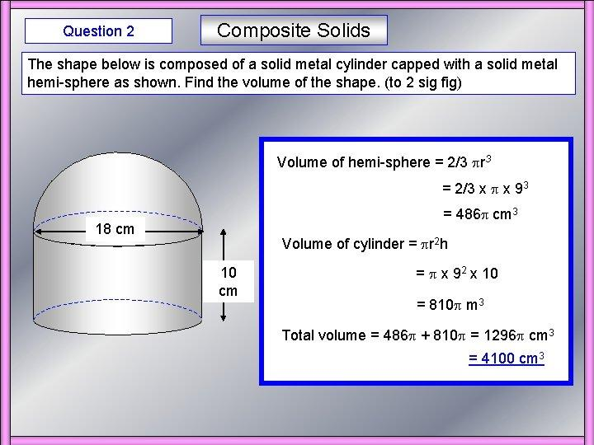
Step 1: Find the cylinder's volume.
$$V_{1}=πr^{2}h=π{\left(3\right)}^{2}\left(8\right)=72π$$
Step 2: Find the hemisphere's volume.
$$V_{2}=\frac{23}{π}r^{3}=\frac{23}{π}{\left(3\right)}^{3}=18π$$
Step 3: Add the volumes.
$$V=72π+18π=90π$$
Answer:
$$\boxed{V=90π{\text{ cm}}^{3}≈282.74{\text{ cm}}^{3}}$$
For the exterior surface area, the circular face where the hemisphere meets the cylinder is hidden. The exposed area consists of the cylinder's curved surface, its bottom circular base, and the hemisphere's curved surface.
$$S=2πrh+πr^{2}+2πr^{2}$$
$$S=48π+9π+18π=\boxed{75π{\text{ cm}}^{2}}$$
Example 3: A cuboid with a cylindrical hole
A cuboid measures $10\text{ cm}×8\text{ cm}×6\text{ cm}$. A cylindrical hole of radius $2\text{ cm}$ passes completely through the $6\text{ cm}$ thickness. Find the remaining volume.
Step 1: Find the cuboid's volume.
$$V_{1}=10×8×6=480{\text{ cm}}^{3}$$
Step 2: Find the volume of the cylindrical hole.
$$V_{2}=πr^{2}h=π{\left(2\right)}^{2}\left(6\right)=24π$$
Step 3: Subtract the removed volume.
$$V=480-24π$$
Answer:
$$\boxed{V≈404.60{\text{ cm}}^{3}}$$
The surface area would also include the inner curved wall of the hole, so it cannot be found merely by subtracting the cylinder's complete surface area from the cuboid's surface area.

Geometric representation of composite solids
# Source: AI Source: Provided by: [Data Path: Persons Table -> ID Column: 1, Name_En Column: Motasem Essam] -> From: [ChatGPT] on [7/25/2026]
A composite solid can be represented in several useful ways:
- Component decomposition: show the simple solids that form the object.
- Three-dimensional drawing: display the complete outer shape.
- Cross-section: show the two-dimensional shape obtained by slicing the solid with a plane.
- Net or surface layout: represent suitable exterior surfaces in a flattened arrangement.
- Dimensioned diagram: label component lengths, widths, heights, radii, and other required measurements.
These representations help identify which formulas to use and which surfaces are hidden.

Applications in everyday life
# Source: AI Source: Provided by: [Data Path: Persons Table -> ID Column: 1, Name_En Column: Motasem Essam] -> From: [ChatGPT] on [7/25/2026]
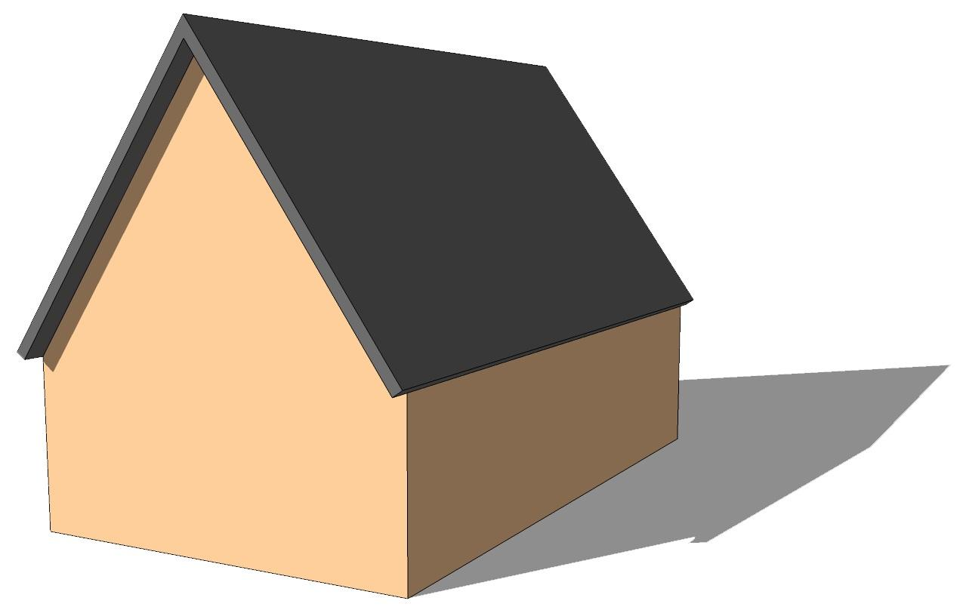
Buildings
Walls, roofs, towers, and architectural structures combine prisms, pyramids, and cylinders.
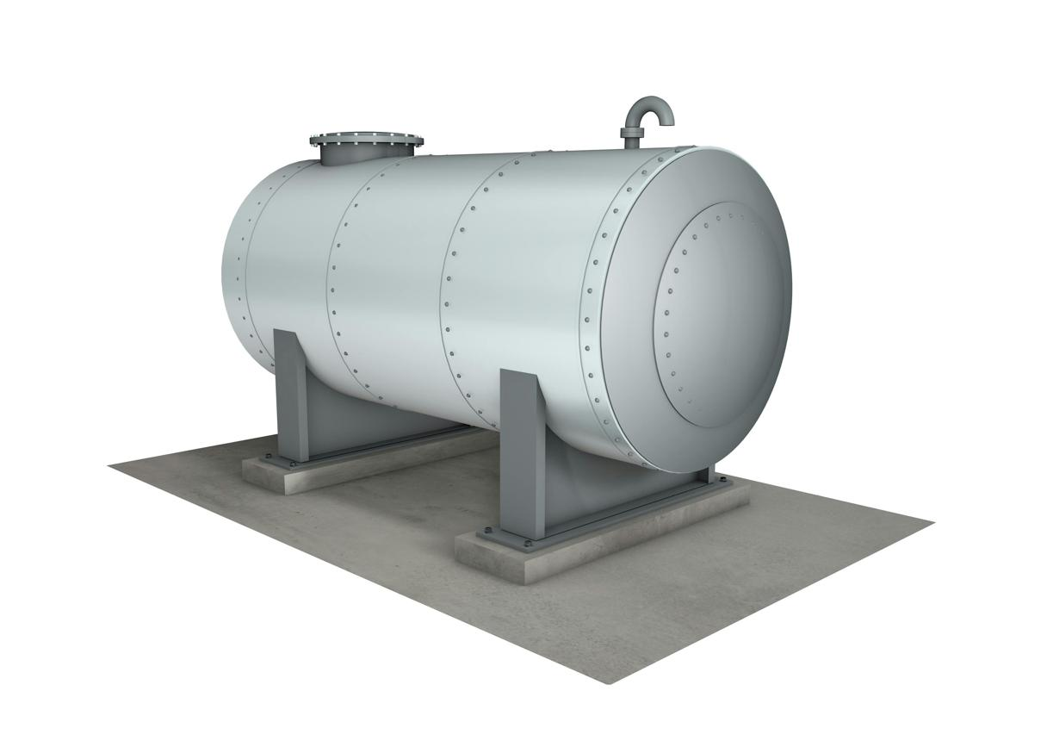
Engineering
Tanks, machine components, supports, and fittings combine multiple geometric forms.
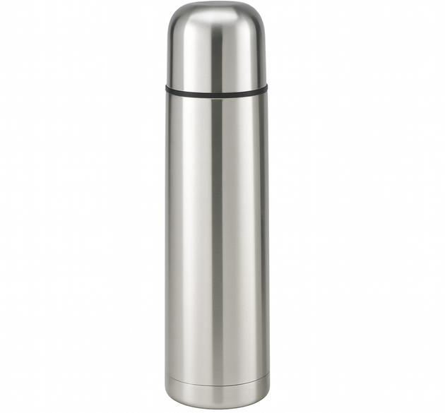
Product design
Bottles, containers, and appliances often contain combinations of curved and flat surfaces.
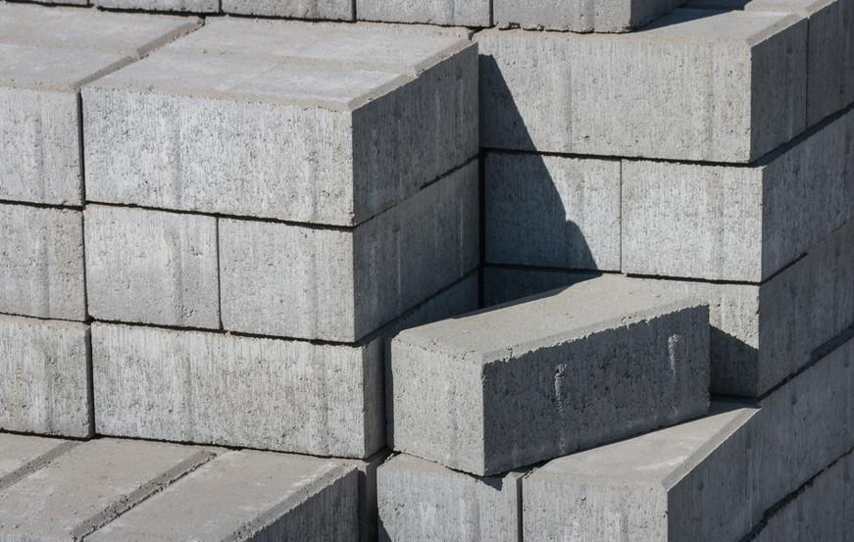
Construction
Stepped foundations, platforms, and retaining structures can be modeled using composite solids.
Composite-solid calculations are useful for estimating material quantities, internal capacity, exterior coating, manufacturing costs, and structural dimensions.

Comparison with related concepts
# Source: AI Source: Provided by: [Data Path: Persons Table -> ID Column: 1, Name_En Column: Motasem Essam] -> From: [ChatGPT] on [7/25/2026]
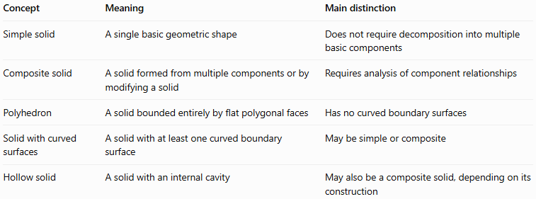
Concept | Meaning | Main distinction
Simple solid | A single basic geometric shape | Does not require decomposition into multiple basic components
Composite solid | A solid formed from multiple components or by modifying a solid | Requires analysis of component relationships
Polyhedron | A solid bounded entirely by flat polygonal faces | Has no curved boundary surfaces
Solid with curved surfaces | A solid with at least one curved boundary surface | May be simple or composite
Hollow solid | A solid with an internal cavity | May also be a composite solid, depending on its construction
A composite solid is defined by its construction or decomposition, not by whether its boundary is flat or curved.

Key points
# Source: AI Source: Provided by: [Data Path: Persons Table -> ID Column: 1, Name_En Column: Motasem Essam] -> From: [ChatGPT] on [7/25/2026]
- Composite solids are made from two or more simpler geometric components, or by modifying a solid.
- Addition combines volumes; subtraction removes volume.
- Overlapping components require correction to avoid double-counting.
- Surface area includes only the exposed exterior surfaces.
- Joining surfaces are normally excluded from the exterior surface area.
- Holes and cavities may contribute additional exposed internal surfaces.
- A clear diagram with all dimensions is often the most important first step.

Conclusion
Composite solids extend the study of three-dimensional geometry by combining simple shapes into more complex objects. Their volume is found by adding, subtracting, or correcting for overlapping component volumes, while their surface area is calculated from the exposed boundary. These principles provide a systematic way to solve practical geometry problems.

